Bazil Uddin Khan 24k-0559 Bscs 3H

COAL LAB 8 TASKS :
TASK#1).
CODE:
Include Irvine32.inc

.data
Msg1 BYTE " Enter An Integer ",0
Msg2 BYTE " Total Positive Numbers are : ",0
Msg3 BYTE " Total Negative Numbers are : ",0
Msg4 BYTE " Total Zero Numbers Are : ",0
PositiveNum Dword 0
NegativeNum DWORD 0

ZeroNum DWORD 0

.code
main PROC

mov ecx,5
mov ebx,1
loopinput :
mov edx,OFFSET Msg1
call WriteString

mov eax,ebx
call WriteInt

mov al,'='
call WriteChar
mov al,' '
call WriteChar

call ReadInt

inc ebx

push eax

loop loopinput

mov ecx,5
mov eax,0
loopcheck :
pop eax
cmp eax,0
Je ZeroVal
jl NegativeVal
jmp PositiveVal

ZeroVal :
inc ZeroNum
jmp ContinueLoop

NegativeVal :
inc NegativeNum
jmp ContinueLoop

PositiveVal :
inc PositiveNum

ContinueLoop :
loop loopcheck

mov edx,OFFSET Msg2
call WriteString
mov eax,PositiveNum
call WriteInt
call Crlf

mov edx,OFFSET Msg3
call WriteString
mov eax,NegativeNum
call WriteInt

call Crlf

mov edx,OFFSET Msg4
call WriteString
mov eax,ZeroNum
call WriteInt

exit
main ENDP
end Main

OUTPUT:
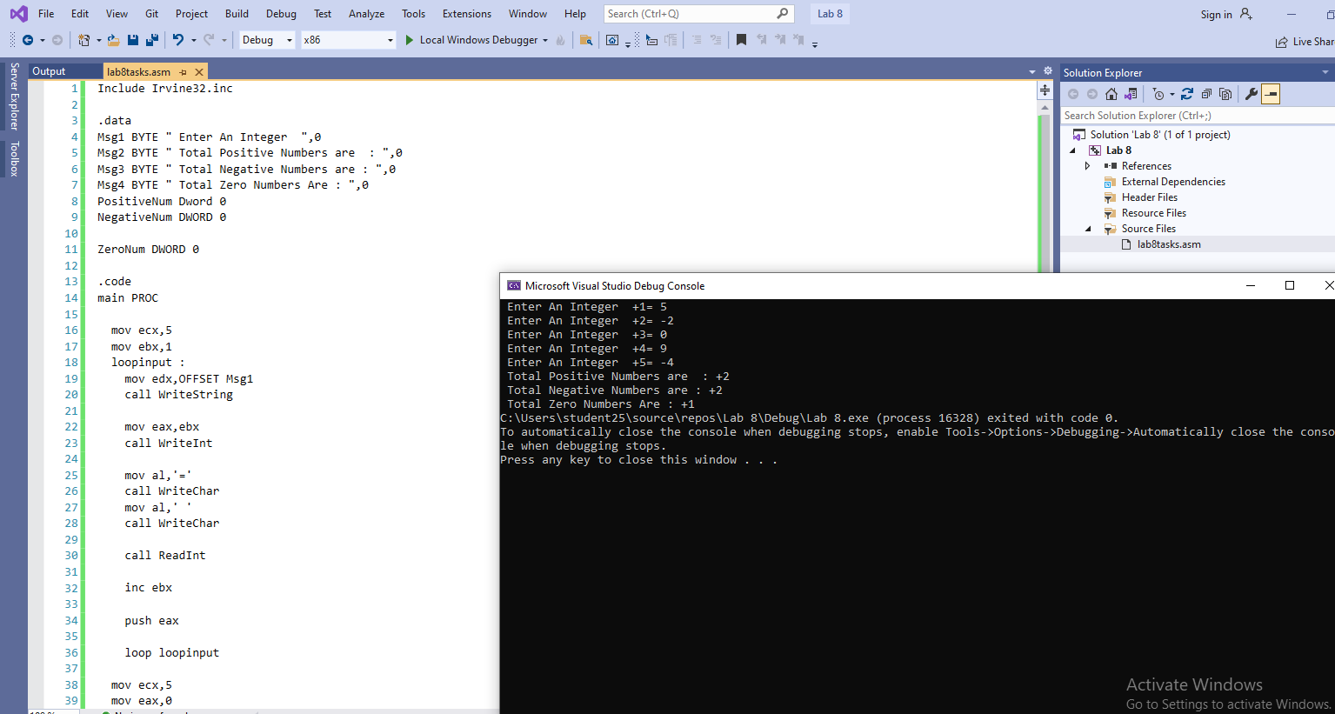

TASK#2).
CODE:
Include Irvine32.inc

.data
Msg1 Byte " Enter An Integer ",0
Msg2 Byte " Reverse Order Is : ",0

.code
main PROC

mov ecx,5
loopInput :
mov edx,OFFSET Msg1
call WriteString
mov eax,0
call ReadInt
push eax

loop loopInput

mov edx,OFFSET Msg2
call WriteString

mov ecx,5

loopReverse:
pop eax
call WriteDec

loop loopReverse

exit
main ENDP
end Main

OUTPUT:
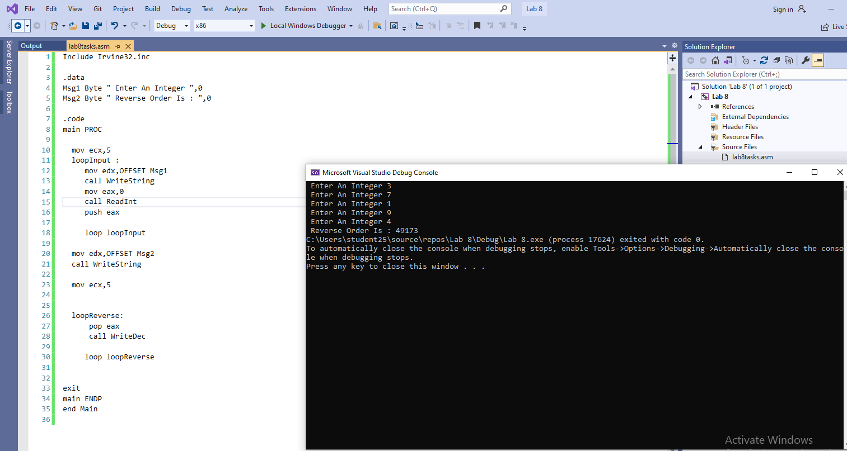

TASK#3).
CODE:
Include Irvine32.inc

.data
Msg1 Byte " Enter An Integer : ",0
Msg2 Byte " Largest Number Is : ",0
Msg3 Byte " Smallest Number is : ",0
Smallest DWORD ?
Largest DWORD ?

.code
main PROC

mov ecx,5

loopInput :
mov edx,OFFSET Msg1
call WriteString
mov eax,0
call ReadInt
push eax

loop loopInput

mov ecx,4
pop eax
mov Largest,eax
mov Smallest,eax

loopFind :
pop eax
cmp eax,Largest
ja Greater
jmp LessCheck

Greater :
mov Largest,eax
jmp IterateLoop

LessCheck :
cmp eax,Smallest
jae IterateLoop

mov Smallest,eax

IterateLoop :
loop loopFind

mov edx,OFFSET Msg2
call WriteString
mov eax,Largest
call WriteInt

mov edx,OFFSET Msg3
call WriteString
mov eax,Smallest
call WriteInt

exit
main ENDP
end Main

OUTPUT:
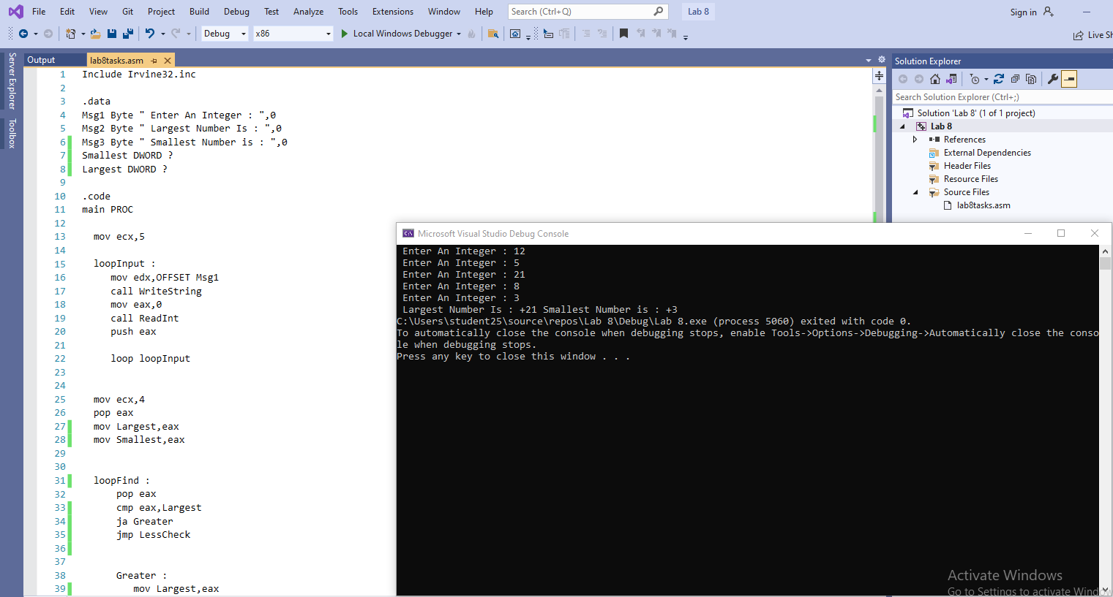

TASK#4).
CODE:
Include Irvine32.inc

.data
InputWord BYTE " Enter a word: ", 0
VowelMsg BYTE " Total Vowels: ", 0
ConstantMsg BYTE " Total Consonants: ", 0
WordString BYTE 50 DUP(0)
VowelCount DWORD ?
ConstantCount DWORD ?

.CODE
main PROC

mov edx,OFFSET InputWord
call WriteString

mov edx,OFFSET WordString
mov ecx,SIZEOF WordString
call ReadString

mov eax, 0
mov VowelCount, eax
mov ConstantCount, eax

mov esi,OFFSET WordString

LoopTraverse:
mov al, [esi]
cmp al, 0
je EndLoop

push eax
push esi

cmp al, 'A'
jb SkipingChar
cmp al, 'Z'
jbe CheckingVowel
cmp al, 'a'
jb SkipingChar
cmp al, 'z'
ja SkipingChar

CheckingVowel:

cmp al, 'A'
je Vowel
cmp al, 'E'
je Vowel
cmp al, 'I'
je Vowel
cmp al, 'O'
je Vowel
cmp al, 'U'
je Vowel

cmp al, 'a'
je Vowel
cmp al, 'e'
je Vowel
cmp al, 'i'
je Vowel
cmp al, 'o'
je Vowel
cmp al, 'u'
je Vowel

pop esi
pop eax
inc ConstantCount
jmp NextChar

Vowel:
pop esi
pop eax
inc VowelCount
jmp NextChar

SkipingChar :
pop esi
pop eax
jmp NextChar

NextChar:
inc esi
jmp LoopTraverse

EndLoop:

mov edx,OFFSET VowelMsg
call WriteString
mov eax, VowelCount
call WriteInt
call Crlf

mov edx,OFFSET ConstantMsg
call WriteString
mov eax,ConstantCount
call WriteInt

exit
main ENDP
END main

OUTPUT:
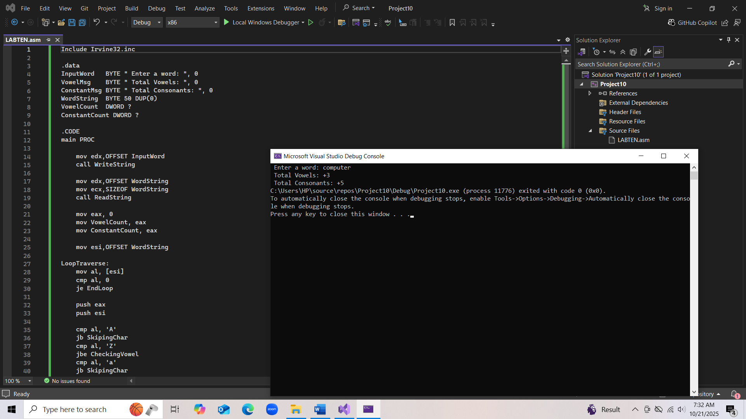

TASK#5).
CODE:
Include Irvine32.inc

.data
Msg1 Byte " Enter Number For Factorial ",0
Msg2 Byte " Factorial Of Number Is ",0
Number Dword ?

.code
main PROC
mov edx,OFFSET Msg1
call WriteString

call ReadInt
mov Number,eax

cmp Number, 0
je Fact1

cmp Number, 1
je Fact1

mov ecx,Number
mov eax,Number

loopFactorial :
push eax
dec eax

loop loopFactorial

mov ecx,Number
dec ecx
pop eax
mov ebx,eax

loopCalculate :
pop eax
imul ebx,eax

loop loopCalculate

mov edx,OFFSET Msg2
call WriteString

mov eax,ebx
call WriteInt

jmp L_exit

Fact1:
mov edx,OFFSET Msg2
call WriteString

mov eax,1
call WriteInt

L_exit:
exit

main ENDP
end Main

OUTPUT:
